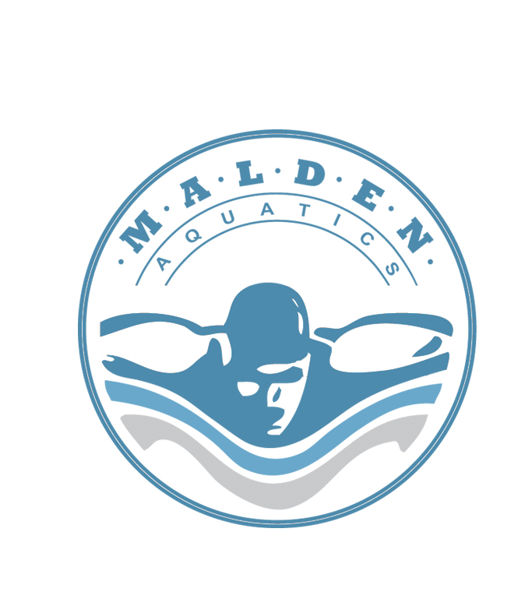
info@maldenaquatics.com
(845) 641-3769

Class Registration Form

OFFICE USE ONLY
Class Name | Date Received
Class # | MO/CHK#
Dates & Times | Confirmation Sent
Location | Certification Sent

Please subtract $27.00 from any Blended Learning (BLC) course fee. You will be required to pay $27.00 on the American Red Cross website when creating your profile and accessing your online material.

Name | Date of Birth
Address | Home phone #
Email Address | Cell #
Registration Fee Amount: $ | T – Shirt Size:

Registration Info: To secure your enrollment within the course full payment is required. This payment can be made by cash, money order or personal check made out to Malden Aquatics Inc. The deposit is totally refundable up to ONE MONTH before the course begins. 50% of the course will be refunded for participants who are not able to pass the pre-test for LGT. All fees will be refunded if the class is cancelled.

Please complete the form and mail in with the registration fee to:

Malden Aquatics, Inc.
Attn: Mathew Malden
4 Hedge Row
New City, NY 10956

Once registration and fees are received, a receipt will be sent confirming your secured placement within the course.

